**LOCATION : NATIONWIDE**

**DATE : 16.06.2017**

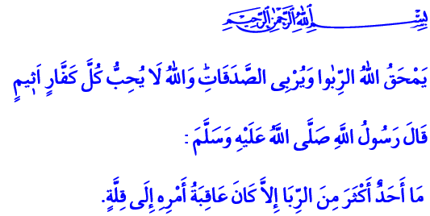

**ZAKAT INCREASES GAINS; USURY CONSUMES IT**

**Honorable Brothers and Sisters!**

Our Beloved Prophet (pbuh) one day said: **“Avoid the seven great destructive sins!”** The companions asked “O Messenger of Allah! What are those seven sins?” The Messenger of Allah gave this answer: **“These seven destructive sins are to join others in worship along with Allah, to practice magic, to kill the life which Allah has forbidden, to devour usury, to eat up an orphan's wealth, to flee from the battlefield when faced with the enemy, and to accuse honorable women of adultery.”[1]**

**Honorable Believers!**

There is a gratitude for each blessing that Our Almighty Lord bestowed upon us. The gratitude for us being created as human is faith. The gratitude for our body is prayer. The gratitude for our health and sustenance is fasting. The gratitude for our property, our wealth is zakat, alms, zakat al-fitr. These are all different ways of spending in Allah’s way.

Zakat is a claim on the property of the rich that Allah gives to the needy. It is the hand that a wealthy Muslim extends to his needy and destitute brother. Alms are the manifestation of sincerity and fidelity towards our Lord and also our brothers and sisters. To put it shortly, spending in the way of Allah is to be aware of the fact that the blessings, the wealth is entrusted to us by Allah. It is the means of making perishable earthly possessions eternal. It is also to deeply embrace the fellowship between believers and to experience and maintain it in a most beautiful way.

**Dear Muslims in the Mosque!**

Zakat and alms are obligatory in our holy religion Islam while usury is forbidden. Usury is to gain unjustly without any work or any effort. Our Lord announces in the Holy Quran the exemplary fate of those who are enslaved by usury:

C:\Users\ahmet.sunetci\Desktop\Adsız.2.png

**“Those who eat usury will not stand (on the Day of Resurrection) except like the standing of a person beaten by Satan leading him to insanity.”**

**C:\Users\ahmet.sunetci\Desktop\Adsız.3.png“That is because they say: ‘Trade is just like usury.’”**C:\Users\ahmet.sunetci\Desktop\Adsız.4.png **“Whereas Allah has permitted trading and forbidden usury.”[2]**

**Brothers and Sisters!**

Spending in Allah’s way will bring one the key to heaven. Usury leads one towards Allah’s wrath and brings great loss. Because giving is to share the wealth for the sake of Allah. It is to sacrifice on this path. Usury is to lose the belief that honest effort is sacred.

**Dear Believers!**

Our Almighty Lord said in the Holy Quran: C:\Users\ahmet.sunetci\Desktop\Adsız.5.png **“God deprives interest of any blessing, and blights it, but makes alms-giving productive. God does not love any obstinate unbeliever, any obstinate sinner.”[3]**

This verse of our Lord shows us that even though giving seems like it decrease from the wealth, it actually increases it many times more and makes it fruitful. Usury might seem to cause an increase in wealth but it actually reduces and consumes it.[4] Aren’t the numerous defaults happening today, the families being dragged into crisis, the efforts that get lost a result of the usury that is unjust profit?

**Esteemed Muslims!**

Then come! Let us seek the ways of becoming one of the righteous by giving the things we love in the way of Allah. Let us strengthen our loyalty to Allah with our zakat, alms and zakat al-fitr. Let us make our Ramadan, our life fruitful with the material and nonmaterial things we share. Let us avoid any kind of unjust and forbidden gain, especially usury.

**Brothers and Sisters!**

The sorrow of separation has covered our hearts in these days as we get close to the end of Ramadan; its beginning is mercy, its middle is forgiveness and its ending is salvation from hell. The sacred month of Ramadan gives us the night of Al-Qadr, the night that is better than a thousand months, as a present before it leaves. We are going to observe the night of Al-Qadr on the end of Wednesday next week, which comes every year to elevate us. Come! Let us turn this night, in which our book of Life, the Quran was first revealed, into an opportunity to reflect upon ourselves, to ask forgiveness and mercy for our sins.

I’d like to take this opportunity to congratulate your night of Al-Qadr and I ask Allah to make this blessed night an occasion for goodness.

1. Buhârî, Vesâyâ, 23.
2. Al-Bakara, 2/275.
3. Al-Bakara, 2/276.
4. İbn Mâce, Trade, 58.

   ***Written by: General Directorate of Religious Services***